### **WARC-Security-Unit Team Agreement**

### **Take Account of Your Strengths:**

Describe at least:

* What are the key strengths of each person on the team?

**Cristiano-** Trustworthy, Optimistic, Honesty.

**André-** professional, organized, team spirit.

**Rodrigo-** patient, honest, persistente

**Wanderson** - perceptive, focused, team mate

* How can you best utilize these strengths in the execution of your project?

**Cristiano-** I can utilize my strengths to foster a positive and conducive team environment, thereby ensuring that I do not let down any of my fellow team members.

**André-** To create a competent, professional and organized team with a good team spirit among colleagues.

**Rodrigo-** I can use my strengths to not let my team down and if something goes wrong, persist in a way of overcoming it.

**Wanderson** -I use my soft and hard skills to help improve the project and help my team members.

**If you are working remotely:**

* When during the day and under what circumstances do you get your best work done? (Morning? Late at night? With other people? Long hours of deep focus?)

**Cristiano-** Anytime with or without people.

**André-** At any time of day, with a good team and a good mood.

**Rodrigo-** I get my best work done anytime of day as long as i can be focused

**Wanderson** - At night, because I work during the day

### **Take Account of Your Areas for Growth:**

Describe at least:

* In which professional competencies do you each want to develop greater strength?

**Cristiano-** My Communication Skills by articulating ideas clearly, adapt my communication style to different situations.

**André-** I want to develop more knowledge and the spirit of organizational and professional leadership.

**Rodrigo**- I want to be better at communicating with a team and be a better professional employee.

**Wanderson** - Improve technics to help the team and delivery the best solution.

* What is an aspect of group projects which has caused each of you stress or anxiety in the past?

**Cristiano-** In the past I verified that timelines can be challenging leading to stress and anxiety.

**André-** It was the aspect of failing or not completing the work to be handed in.

**Rodrigo**- Not completing the work and short timelines give me stress and anxiety

**Wanderson** - I always tried to deal with the deadlines to avoid stress because I always worked in Agile environments.

## **Conflict and Confrontation Plan**

* What will be your group’s process to resolve conflict, when it arises?
* We can speak to each other calmly and sincerely, finding a reasonable solution for all team members.
* How will your group determine whether a conflict calls for intervention or resolution? Is that a collective decision, or one that can be made unilaterally by a single member?
* The group will call for intervention or resolution as a team with a collective decision and a 'last word' if necessary from the team leader.
* What will your team do if one person is taking over the project and not letting the other members contribute?

- I would call the team member to account and try to find out the reason for their attitude and draw attention to what is happening by talking among ourselves and staying calm.

* How will you address concerns with a member who is worried that the group is not reaching a high enough standard?

-We can ask which standard the person is in, and find a middle term for all elements so that they are all on the same page and walking on the same road.

* How will you approach each other and the challenges of the project knowing that it is impossible for all members to be at the exact same place in understanding and skill level?

-We can learn from each other, explaining details and talking about the questions or the problems. By having a team leader who knows the capabilities of each team member and allocates tasks in a way that suits each member's skills.

* How will you raise concerns to members who are not adequately contributing?
* By talking and presenting them some ideas to contribute adequately.
* How and when will you escalate the conflict if your resolution attempts are unsuccessful?
* We can assess the situation by doing an intervention or a team meeting.
* How will you ensure that you are creating a safe environment where everyone feels comfortable speaking up and communicating honestly?
* We can create a safe environment by respecting each other's perspectives even if they differ from our own.

## **Cooperation and Scheduling Plan**

* Knowing that every person in your team needs to understand all aspects of the project, how do you plan to approach the day-to-day work?

- By talking to each other actively and making a daily team plan according to the needs of each team member.

* What hours will you be available to communicate?

- At any time of the day depending on the availability of each team member

* What platforms will you use to communicate (ie. Slack, Discord …)?

- Discord, Slack, GitHub.

* How long are you allowed to work before taking a break?

- Breaks can be coordinated in the moment.

* How will you seek out teammates for assistance when you get stuck?

- By presenting and explaining the problem as simply as possible so that we can work out a solution together.

* How do you expect a teammate to ask for assistance? What resources do you expect them to have already used?

- hope to have open communication with everyone and let them know that they have a team supporting them in the most difficult tasks.

* How will you know if you are falling behind?

- Checking the problems that have arisen so far.

* + What is your plan if you start to fall behind?

- Try to keep up and talk to the team about that.

* What are your team’s expectations for communication after hours and on the weekend?

- The team is open to communicate at any time.

* What is your strategy for ensuring everyone’s voice is heard?

- We can ensure that everyone's voice is heard by actively listening to each other.

**If you are working remotely:**

* How will you negotiate with team members working in different time zones?

-Making a calendar with agreed times according to each member's availability..

* What existing events (doctor’s appointments, childcare, certification tests, etc.) will each person need to work around?

- At the time there's nothing to access. When the time comes we can deal with it.

### **Create a shared Google Calendar:**

* Have each team member fill in:
  + Any scheduling conflicts which will take them away from work during core work hours
  + Any time periods they expect to be working outside of core hours
* As a team, create events for:
  + Morning standup
  + Afternoon check-in (optional)
  + Practice presentation with your instructor
    - Day 04 of project week for in person courses, or a few days before the final presentation – communicate with your instructor about scheduling)
  + Deadline for submitting deliverables for instructor review
    - Day 03 of project week for in person courses – deliverables only need to be complete enough for your instructor to give feedback
  + Final Presentations (you will need to be online 15-30 minutes before the event officially begins, so account for that)
  + Any other practice sessions, team meetings, etc.

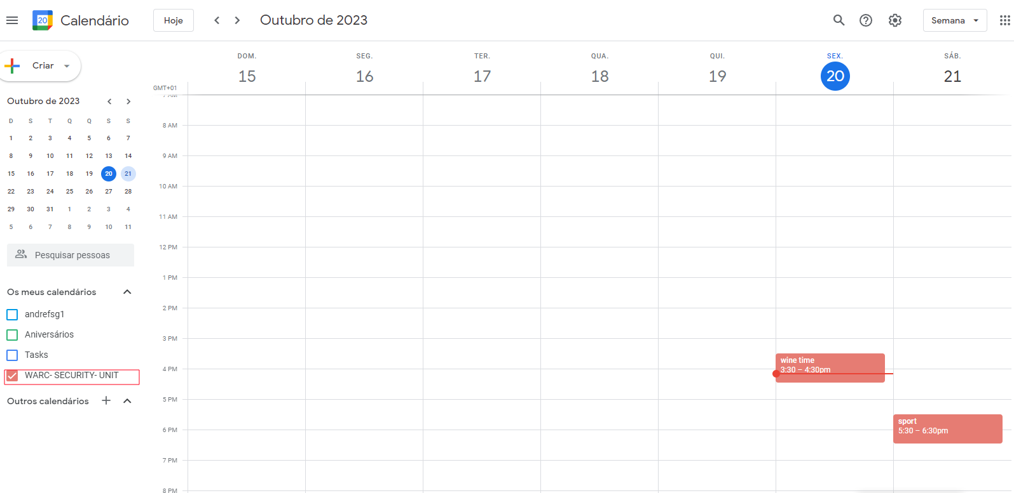

## **Step 6: Work Plan**

Explain your work plan to track whether everyone is contributing equally to all parts of the project, and that each person is working on “meaty” problems. This should prevent “lone wolf” efforts and “siloed” efforts.

* How will you identify tasks, assign tasks, know when they are complete, and manage work in general?

- We can identify tasks by checking GItHub and talking to each other.

* How often should teammates be pushing their work to GitHub, demonstrating the configurations, or otherwise *showing* their team the products of their work?

- We can communicate about our work as we are doing it and have the team's opinion to make any corrections if necessary.

* What project management tool will be used?

- We are going to use GitHub for that purpose.

* How will each teammate document their progress on tasks so that work can be exchanged, assisted, and/or collaborated on effectively?

- I think that we are going to create documents and share them with each other.

### **Git Process**

Plan out what your team’s Git workflow looks like for scripting, SOPs, documentation, and other deliverables.

Describe at least:

* What components of your project will be recorded in a Google Doc?

- The project flow and steps taken.

* What components of your project will live on GitHub?

- Everything, mainly code and necessary configurations

* How will you structure the GitHub organization and the repos inside of it?

-By making sections in the organization repo.

* + If it’s helpful, include a drawn diagram or topology.

-We have created it.

* How will you share the organization and the repositories with your teammates?

- By making them the Admin of the organization.

* What is your Git flow? How will you commit your work to GitHub?

- By making an elaborate tree and organized work.

* How will you seek help if you encounter a gituation?

- My talking to my teammates and if not resolved asking external help.

**Team:**

**André Graça**

**Cristiano Garcia**

**Rodrigo Brasil**

**Wanderson Lima**